**STUDY TOUR REPORT 2019 – 2023**

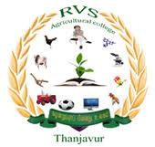

**AEX 402**

**ALL INDIA STUDY TOUR (0+1)**

**RVS AGRICULTURAL COLLEGE**

**(Affiliated to Tamil Nadu Agricultural University,Coimbatore) Usilampatti Village , Manayeripatti(po) , Sengipatti(via), Thanjavur – 613 402.**

# PREFACE

The present report is a compilation of the events, places visited and activities of a 18 days Educational trip which was organized by the Department of Extension , RVS Agricultural college, Thanjavur from 5th February 2023 to 23rd February 2023 with the aim to aid the students to acquire basic knowledge of the Research Institutes and Equip them with the experience about various Culture so as to imbibe and enhance one’s reach and impact in the society.

The Department of Extension , Tamil Nadu Agricultural University as it emphasizes not only on the curricular syllabus but also the holistic development to the undergraduates of the Department. So, the department organizes an educational excursion for the B.Sc.(Hons)Agriculture 4th year, For the Academic year 2022-2023 , 117 members of RVS Agricultural college have participated in the tour. The Students were Accompanied by the faculty members (4) of the department.

**Faculty members :**

1. Ms.S.Shanthi , M.Sc.,(Asst. Prof)(AEX )
2. Dr.M.Bharathi raja, Ph.D.,(Asst. Prof)(HOR)
3. Dr.M.Udhayakumar, Ph.D.,(Asst. Prof)(AEC)
4. Ms.A.Nivetha, M.sc.,(Asst. Prof)(PAT)

# ACKNOWLEDGEMENT

To take study tour is a part of our Under Graduate program.,it is quit valuable and important aspect to provide practical knowledge to the students of agricultural studies.

We extent our sincere thanks to our Principal Dr.P.Pandiyarajan , Our Teacher in-charge Ms.S.Shanthi for making it possible to conduct the study tour 2022 - 2023. Our Heartful gratitude to Dr.M.Bharathi raja and Dr.M.Udhayakumar for the continuos care , support and valuable assistance throughout the trip. Our sincere thanks to Mr.Sreenivasan , Mr.Gokul , Mr.Dhiwakar for their selfless and relentless service , without their assistance the tour would not have been a success.

CONTENTS :

|  |
| --- |
| * A Train Journey to Remember |
| * Indian Institute Of Horticultural Research (IIHR) |
| * International Crops Research Institute For the Semi-Arid Tropics (ICRISAT) |
| * National Institute Of Plant Health Management (NIPHM) |
| * Charminar |
| * Birla Mandir |
| * National Institute And Agricultural Extension Management (MANAGE) |
| * National Academy Of Agricultural Research Management (NAARM) |
| * Golkonda Fort |
| * Ramoji Film City |
| * Taj Mahal |
| * City palace |
| * Hawa Mahal |
| * Jal Mahal |
| * Amber fort |
| * National Bureau of Plant Genetic Resources |
| * Indian Agricultural Research Institute |
| * National Dairy Research Institute |
| * River rafting |
| * Ganga Aarti |
| * Indian Institute Of Soil And Water Conservation ( IISWC ) |
| * Forest Research Institute ( FRI ) |
| * Central Potato Research Institute (CPRI) |
| * Kufri snow point |
| * Mushroom Centre |
| * Sukhna Lake |
| * Wagah Border |
| * Golden Temple |
| * ICAR Museum |
| * ICAR Library |
| * India Gate |
| * Indira Gandhi Memorial |
| * Gandhi memorial |
| * Return Journey |

# RVS AGRICULTURAL COLLEGE . THANJAVUR – 613 402

### DAY 01 - 05.02.2023

On 5th of February , with excitement , our group of 117 members boarded Mysuru express ,Train No.16231 from Thanjavur for an eventful journey to Bangalore .

All the members , completely snuggled up in sweaters and boarded the train at 19:10 hours ready for a 13 hours journey to cover 500 km.

The cold wind seemed to bid us farewell as it swept the train with spine-tingling shivers and warm under-breaths. The tall buildings and the busy roads confirmed the end of the enjoyable journey on the 6th February as we entered Bangalore.

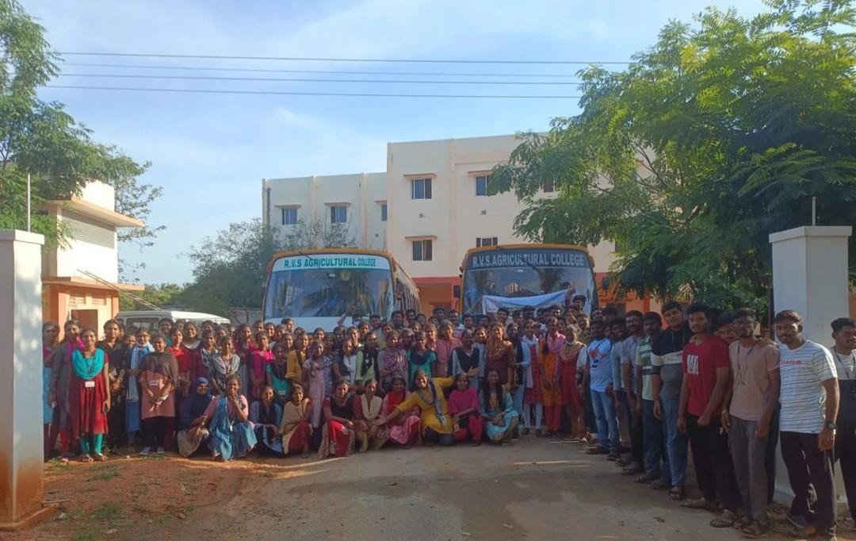

### DAY 02 - 06.02.2023

We Reached Bangalore at 5.40 a.m. in the morning. As we exit the junction(Bangalore) , we were surrounded by swarms of auto-rickshaws. Then we reached the Hotel for refreshment. Our first visit was to the INDIAN INSTITUTE OF HORTICULTURAL RESEARCH where Mr. P. M. Reddy is the scientist at IIHR. There he briefed about the achievements of the Pioneer Horticultural Research and Development Institution. He also showed us a video on varieties and hybrids released by them. The Institution has a registered brand name where the varities and hybrids are released in the name of Arka which means The IIHR deals with about 54 Horticultural crops which includes fruits like Mango , Guava , Papaya , Jack , Anona and vegetables like Brinjal, Chillies, Tomato, Onion, etc., Many Ornamental Hybrids are also released here at IIHR. We were inspired by the scientists of IIHR, Bangalore. They were encouraging us to shine with flying colors for our future.

Then by 4.45 pm, we reached KSR Bangalore city railway station for catching our next train Kacheguda express to head for our further visits and sightseeing in Hyderabad.

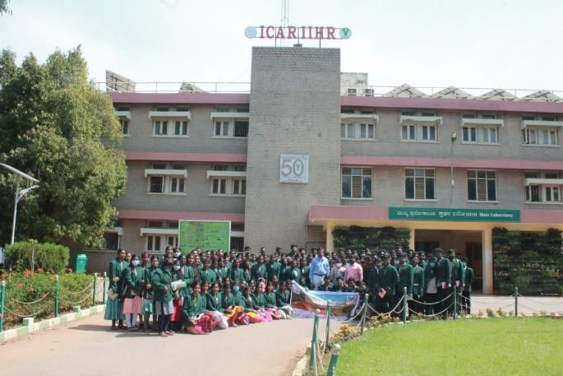

6 | P a g e

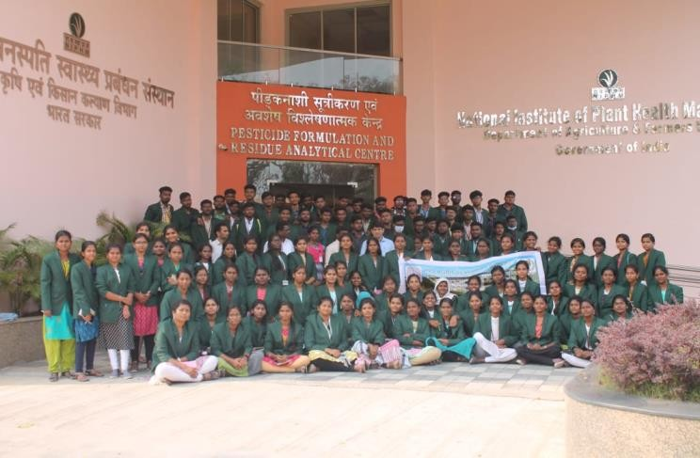

### Day 03 - 07.02.23

We arrived to the Kacheguda station at 5.40am in the morning and went straight to the hotel for refreshments. We reached INTERNATIONAL CROPS RESEARCH INSTITUTE FOR THE SEMI-ARID TROPICS (ICRISAT), Hyderabad and

firstly we saw the varieties which were developed by this premier institute. After viewing their varieties we then went to their man-made lake. Then after touring around the campus, we clicked a group photo. We were thankful for our Field Guide Sir for his valuable time and motivational words.

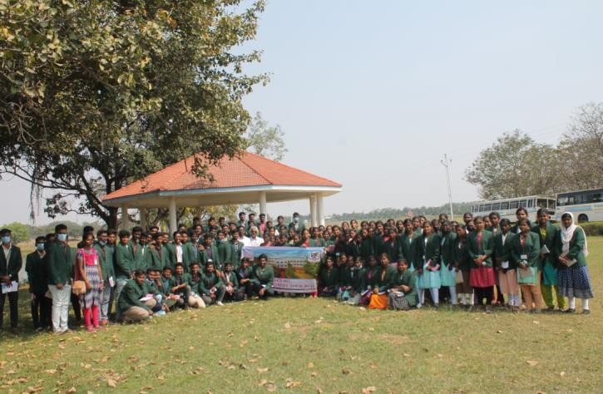

Then in the afternoon, we started from ICRISAT and went to NATIONAL INSTITUTE OF PLANT HEALTH MANAGEMENT (NIPHM). There we were made to sit in an auditorium and explored the campus virtually via a 10 minute video clip. The institute has contributed enormously for the protection and management of crops against various abiotic and biotic factors. Then we also visited their Pesticide Formulation and Residue Analytical Centre. This day was fruitful for all of us.

The sky was pitching down slowly as we went to Charminar which means

‘Four Minarets ‘. This is one of those monuments which looks so simple and plain in pictures but in reality are amazing . When we saw the Charminar we were not prepared to be assaulted by such beautiful craftsmanship and uniqueness. It was predominantly a womans turf. We experienced an unbroken tradition of bargaining at the bazaars , inspite of the vendors sternly sticking to their quote and displaying ‘’fixed price ‘’ boards. It is a place like no other , that will not rest until it awakens the shopaholic and foodie that we thought we never were.

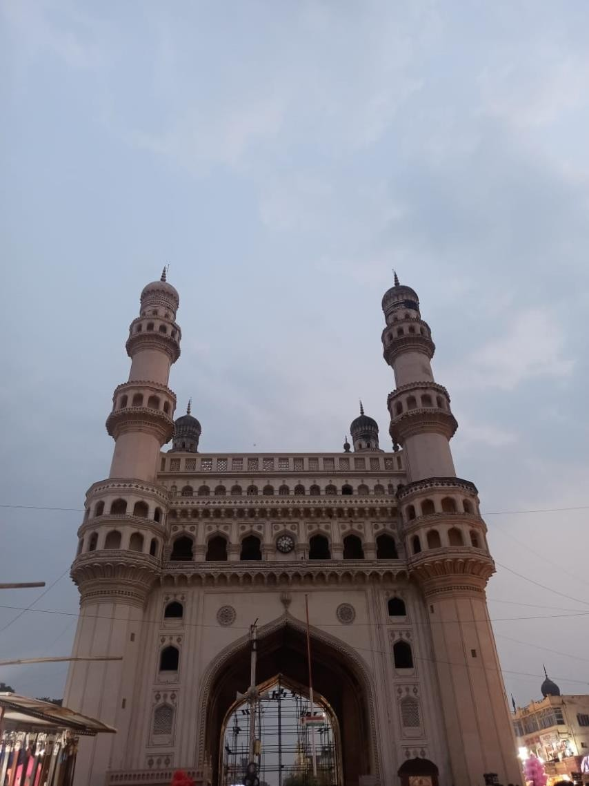

### DAY 04 - 08.02.23

We went to the Birla temple at the morning .The temple was built in a beautiful white marble on a hill top . The view from the top floor is amazing wherein we have seen the whole city of Hyderabad including the Hussain Sagar Lake and Lumbini Park with Buddha Statue . It feels very peaceful once you reach inside the main temple . we were so fascinated to see such big carvings of the temple . Overall a wonderful experience both seeing the temple and the view of the city from the top of the temple .

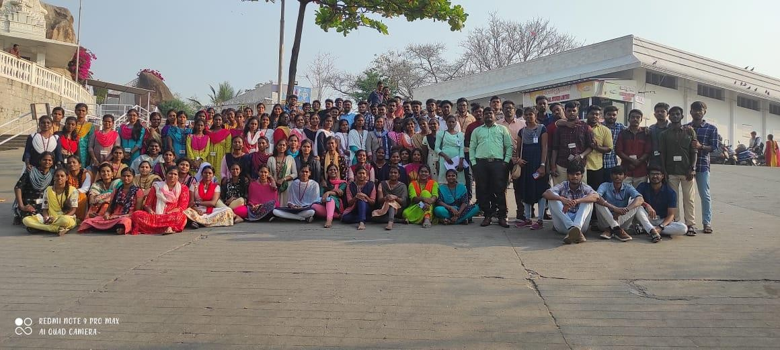

After that we went to NATIONAL INSTITUTE AND AGRICULTURAL EXTENSION

MANAGEMENT (MANAGE). It was formerly called as National Centre for Management of Agricultural Extension. It is an autonomous extension and agribusiness management institute.

At MANAGE, we were introduced to their PGDM course which were offered to students based on their CAT score. There were different levels (CAT SCORE, Essay Writing, Group Discussion and Personal Interview) for students to pass and get admission into their student-friendly proud programme offered for us. This Institution strictly follows case study based learning. The Director (Agricultural Extension) Dr.Saravanan Raj Sir was heartwarming host for all of us. Indeed the career spectrum of the students have been widen by his words.

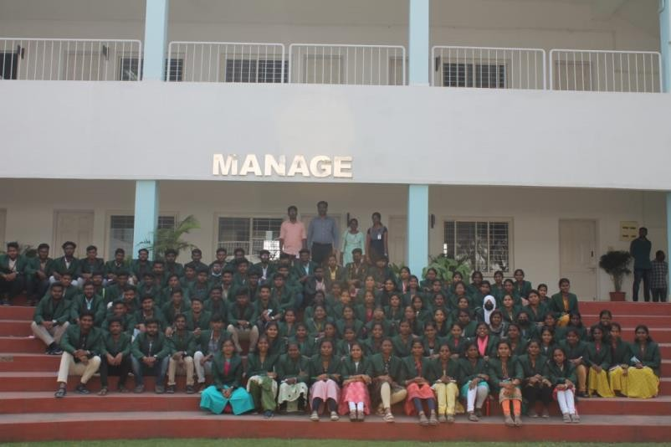

After visiting MANAGE, we went to NATIONAL ACADEMY OF AGRICULTURAL RESEARCH MANAGEMENT (NAARM). This national level service training institute provides training for ARS cadre. It was established by the Indian Council of Agricultural Research (ICAR) in 1976, to sort issues regarding agricultural training, research, development and education management. Then it started to impart training to the entrants of the Agricultural Research Service.We got to know the placements details of NAARM . We were inspired by seeing the campus structure and the acticities of the students.That was a quite different experience watching the college life that we have dreamt of in real . There we got to hear a soothing tamil speech after 3 long days and we couldn’t forget how the way we smiled after hearing our mother tongue in other state .

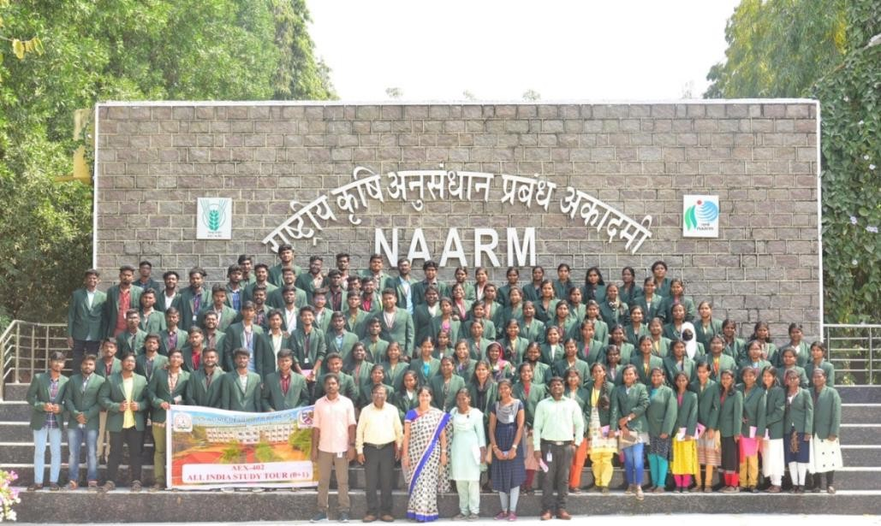

After visiting NAARM we went to Golconda Fort, which is undoubtedly one of the most magnificient fortress complexes in India. We had a great tired-some time with our friends.The fast winds helped us tackle the sticky , sweating temperature as we proceed for the fort of Golkonda. But visiting such a place of Historical Heritage is worth our time, energy and space on our travel diary. We climbed a lot and lot of stairs and also walked miles to reach the destination.

After climbing to the top of the fort we saw a beautiful scenery and from there we saw the entire city in a sinlge view .It was totally mesmerizing and Pleasant.

There’s a lot of interesting facts of the fort , ‘’Walls have ears’’. Also the two minars of Charminar are visible from the fort . Overall it was an amazing experience.

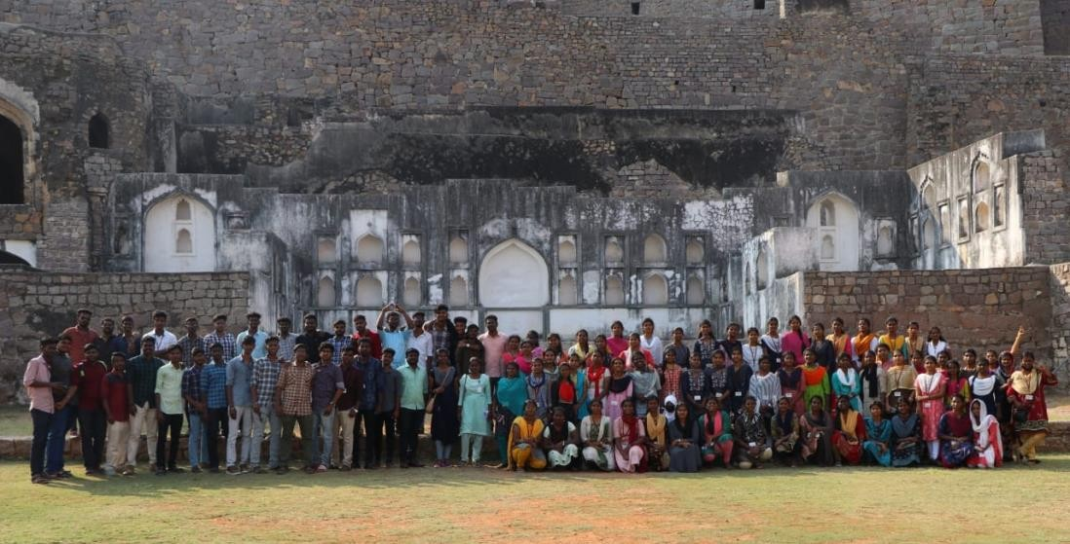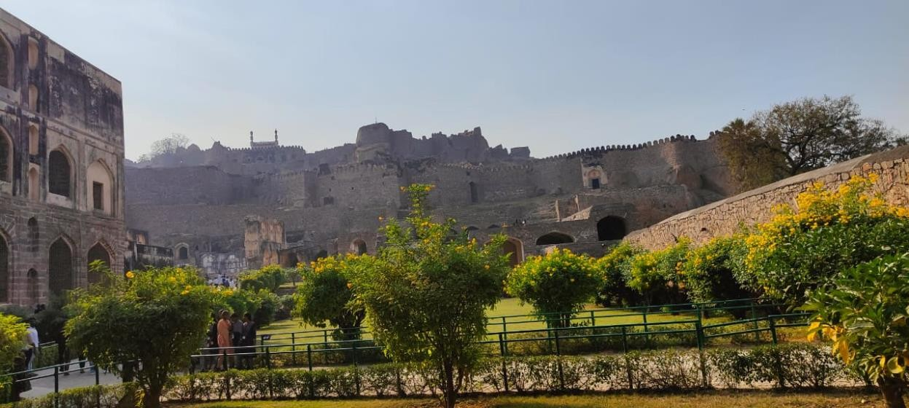

### DAY 05 - 09.02.23

Dressed as colourful as flowers we were taken to Ramoji Film City which was a home to the world of believing glamorous filmy sets, fun rides, games, daily live shows, high-action stunts, thematic food courts, shopping boutiques and signature hospitality in its hotels dotting the dreamscape. The vast area was toured in their special Ramoji bus where we enjoyed Bahubali sets, experienced the whole of India without actually going to each state. From murmuring why the hell did they brought us here and not to wonderla to leaving it with a heavy heart

, we had a great day there . Some of us got their first tattoos and fulfilled their desire on putting it . Indeed this day will be forever etched in our hearts. From there, we went to railway station for departing to Agra.

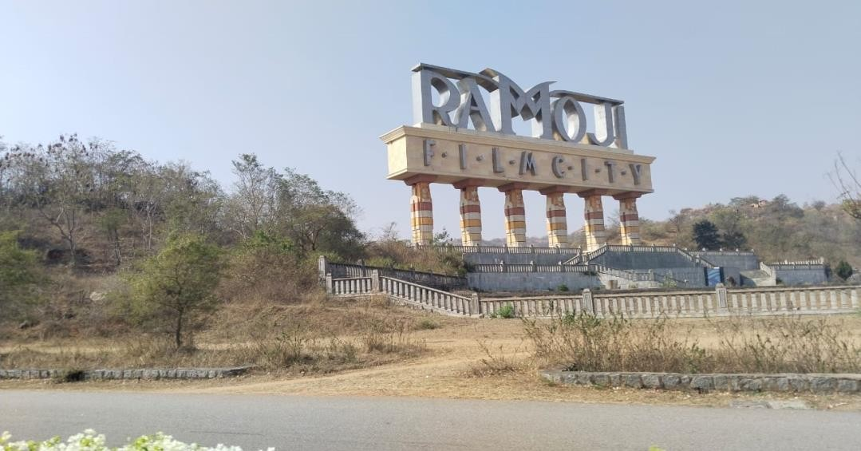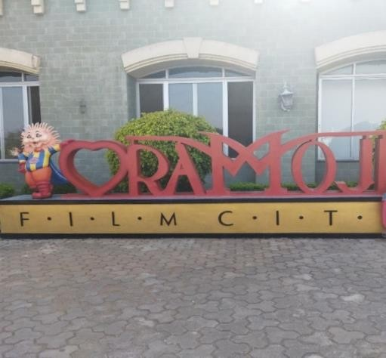

### DAY 06 - 10.02.23

Full day train travel to Agra in Dakshin Express which had departed at 11pm the previous night. It was long yet enjoyable journey on the train.We played games like cards and ludo with our friends .we made lots of fun and laughter inside the train.

### DAY 07 - 11.02.23

We visited the TAJ MAHAL which is located on the right bank of the Yamuna River in a vast Mughal garden that encompasses nearly 17 hectares, in the Agra District in Uttar Pradesh. It was built by Mughal Emperor Shah Jahan in memory of his wife Mumtaz Mahal with construction starting in 1632 AD and completed in 1648 AD, with the mosque, the guest house and the main gateway on the south, the outer courtyard and its cloisters were added subsequently and completed in 1653 AD.Having heard of the beaty and the stories around this wonder of he world , it had been our long awaited dream to come face to face with this famed monument of love.In its simplicity and austerity , for a while we forget all about our surroundings and we must have dropped our jaw wide open in woner I guess . It was pleasant for the eyes for all of us.After that we travelled to Jaipur via bus at midnight and check in to the hotel.

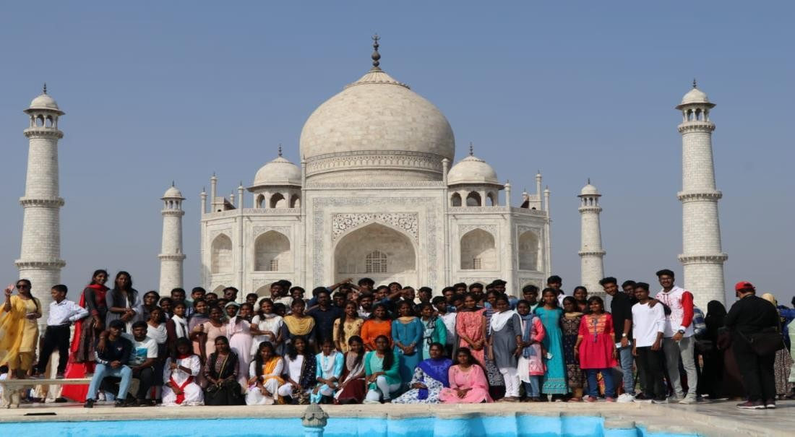

### DAY 08 - 12.02.23

We first went to city palace which was followed by hawa mahal and Jal mahal.

We ended the day by visiting the majestic amber fort. The view of the Hawa mahal was very nice. It is one of jaipurs most incredible attractions. Its kind of wall with lots of windows in it.

Amber fort is one of the prominent attraction to visit .The view of the Amber fort covered by the lake at the entrance was very beautiful . Also we witnessed the shooting spots of some prominent movies like Jodha Akbar . And then we departed to Delhi via bus.

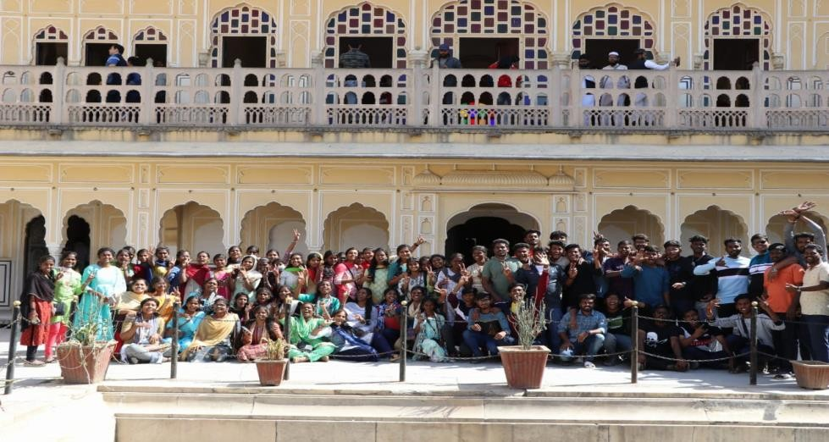

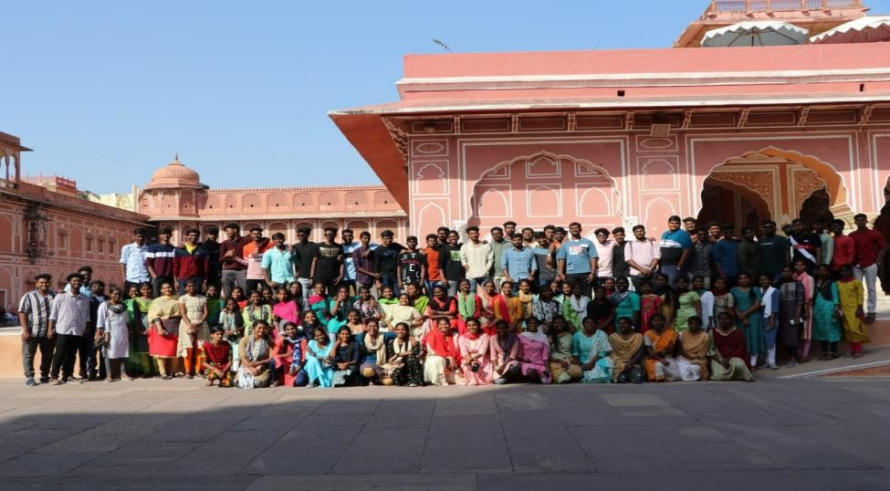`

### DAY 09 -13.02.23

We started this day by visiting ICAR-NBPGR (NATIONAL BUREAU OF PLANT GENETIC RESOURCES ) Museum - There we saw many types of seeds and its originations in india. Different kinds of seeds were collected and preserved at the museum. We have also seen the cold storage unit with proper measures and protocols of the institution. It was very informative.

Next we have visited the INDIAN AGRICULTURAL RESEARCH INSTITUTE.We observed their crop cafeteria maintained at the institution. There we have seen the crops like wheat, Bengal gram,Mustard,Radish,Winter bean,Broccoli,etc.,since it was our first experience on seeing crops like wheat and Mustard. It was good experience.

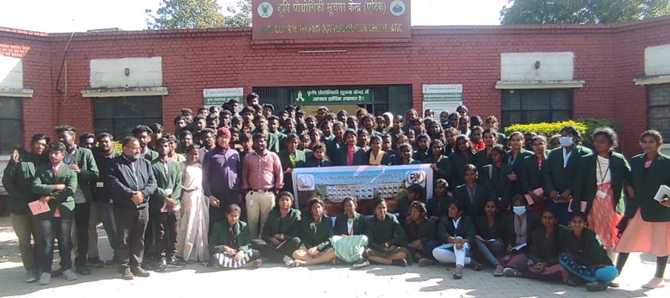

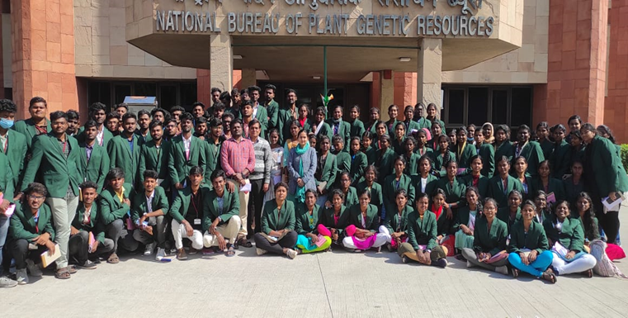

### DAY 10 - 14.02.23

We started travelling to Karnal by bus. At Karnal, we visited NATIONAL DAIRY RESEARCH INSTITUTE where the production of milk and milk based products. We saw different buffalo breeds. The production, processing and management processes were explained to us in detailed manner. We felt obliged to listen to the words of a very respected senior scientist working there.

From Karnal, we started to Haridwar and reached there around midnight 12 am.

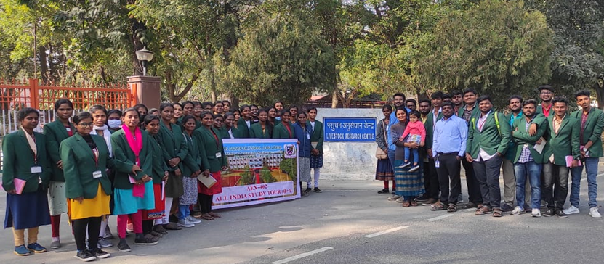

### DAY 11 - 15.02.23

We went to river rafting in Rishikesh. The change in the temperature was very much evident. One of the most amazing thing we had done in our lifetime .It was a thrilling experience when we face the real power of water in various level of water . Also it feel so nice when we swim in the middle of the Ganag river . The sense of achievement we got was priceless . We also visited Shiv Mandir and Lakshman Jhula. It was a surreal experience. We ended the day by going to the temple where Ganga Aarti happens. It was beautiful to see so many flames from the candles burning brightly against the backdrop of Indias most revered river .

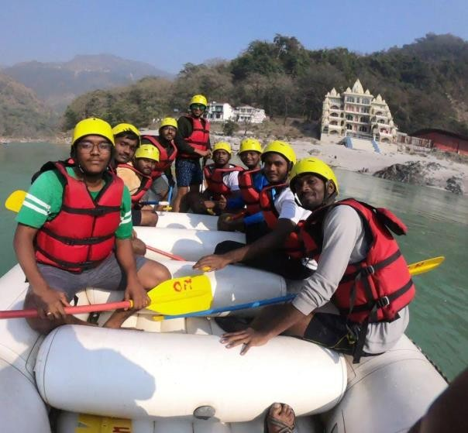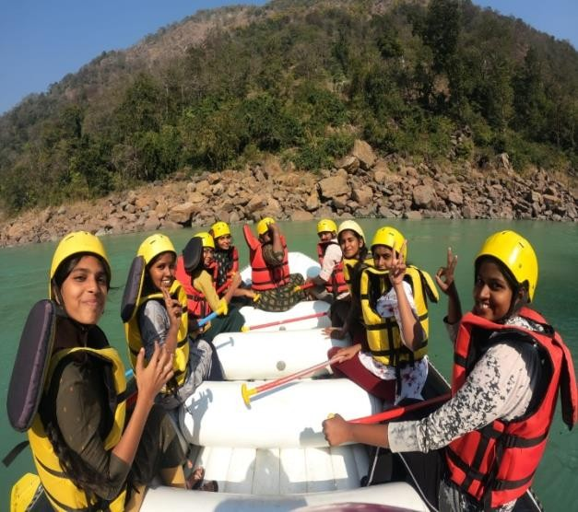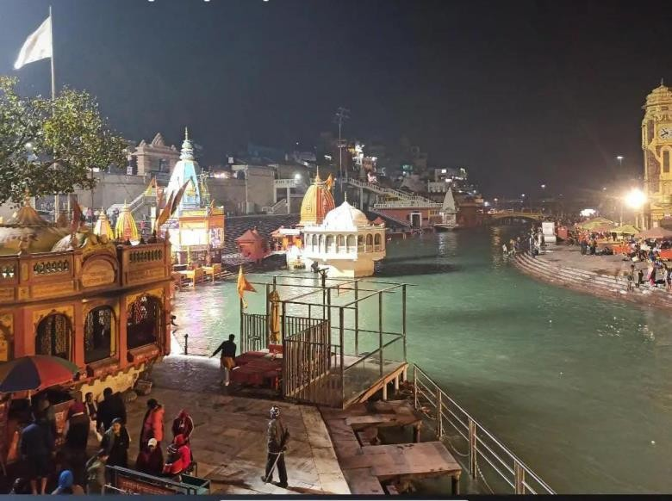

### DAY 12 - 16.02.23

We went to the ICAR-INDIAN INSTITUTE OF SOIL AND WATER

CONSERVATION (IISWC) which was established on 1st April, 1974. This institute have focused on developing strategies to improve, enhance the degraded soils health and tackle various problems related to soil and water conservation.

Then we visited FOREST RESEARCH INSTITUTE (FRI) Museum. We explored the five sections of the museum .It was a joyful experience. Then we started to Shimla by bus.

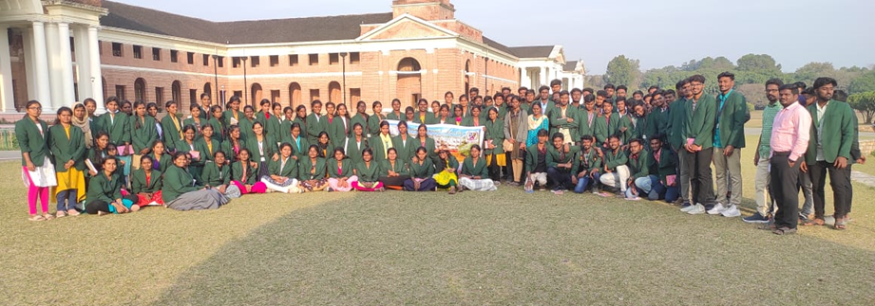

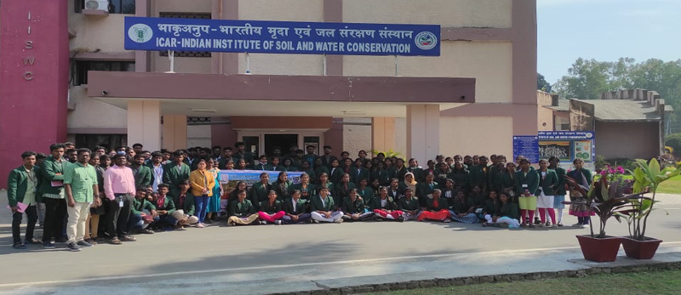

### DAY 13 – 17.02.23

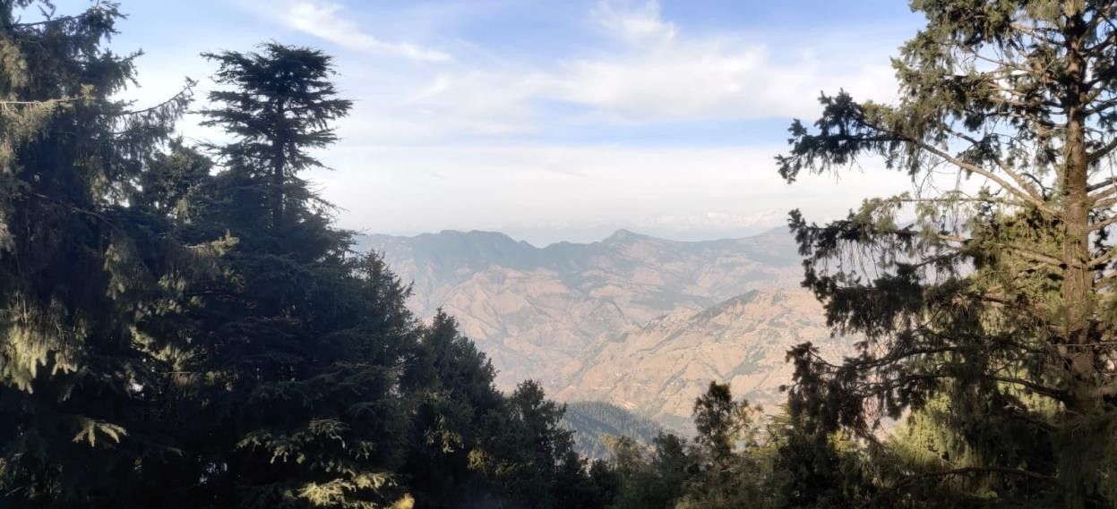We reached Shimla around 6.30 a.m. and we visited the CENTRAL POTATO RESEARCH INSTITUTE.It was established during August 1994 at Patna initially.The institute was later on,shifted to Shimla ,Himachal Pradesh in 1956 in order to facilitate hybridization work in potato breeding and maintain seed potato health.It was transferred to the ICAR in 1966.Then we went to the snow point located at Kufri .There we enjoyed a lot by experiencing the horse ride and also seen the Himalayan mountains through the telescope.And also we have experienced some adventurous games there.

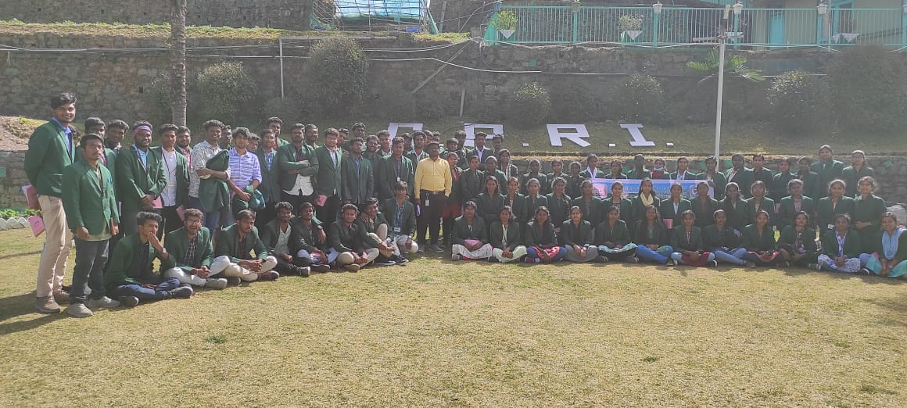

### DAY 14 – 18.02.23

On this day we went to MUSHROOM CENTRE in Solan.There we have seen different types of mushrooms which are Button mushroom, Oyster mushroom, Ganoderma and Shitake mushrooms .They have explained about the Spawn production and their production technologies. Also we have got to know about the various value added products of mushroom and their medicinal benefits.

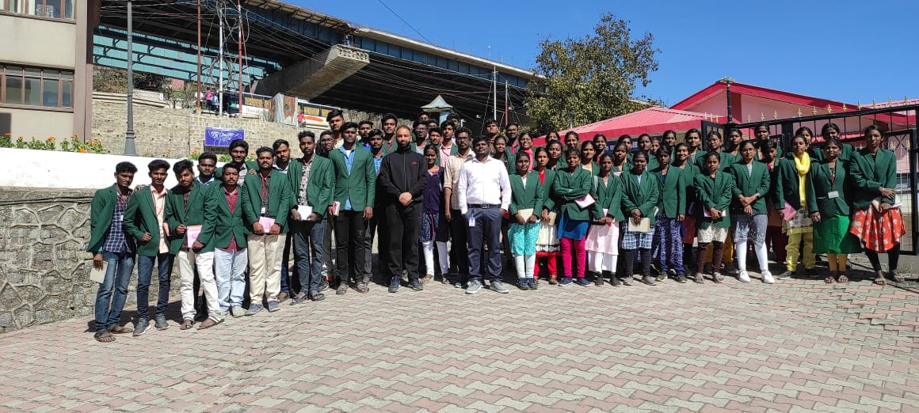

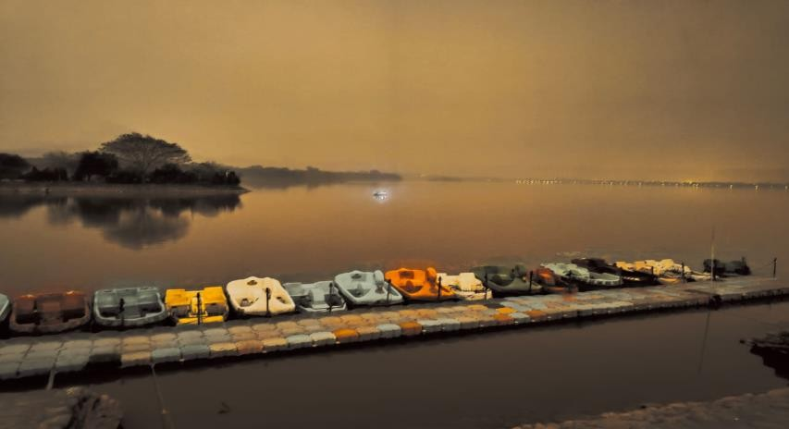At the evening hours we have visited the SUKHNA LAKE located at Chandigarh.It is one of the best place for evening walk with friends . We enjoyed the food court , small play area with rides and created some memorable experience over there.Also we find some artists who made a pencil sketch with in few minutes. It was a delightful experience of seeing the scenic beaty of nature .

### DAY 15 – 19.02.23

We reached Wagah Border at 4.30 p.m. in the evening time and experienced the lowering of the flags ceremony at the Attari Wagah Border.Under the supervision of BSF , this ceremony was followed since 1959. The drill is characterized by elaborate and rapid dance-like manoeuvres and raising legs as high as possible. We witnessed the Aggression , emotion in the air . This was totally a patriotic colourful experience. The air of the Wagah Border spreads the fragrance of Patriotism into us and the shouting of slogans which injects the feeling of brotherhood into the nerves .

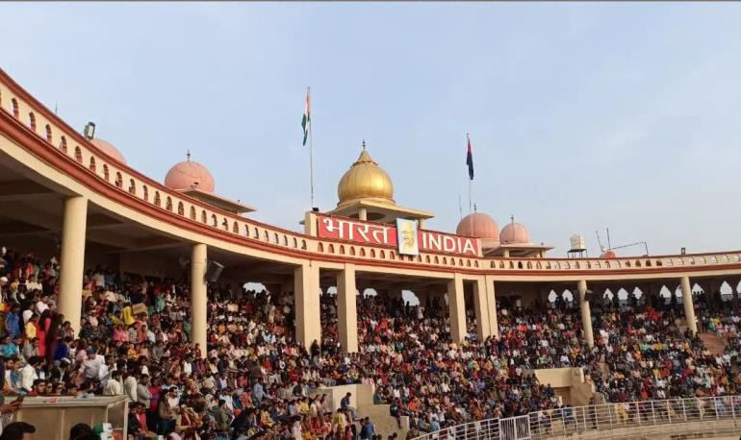

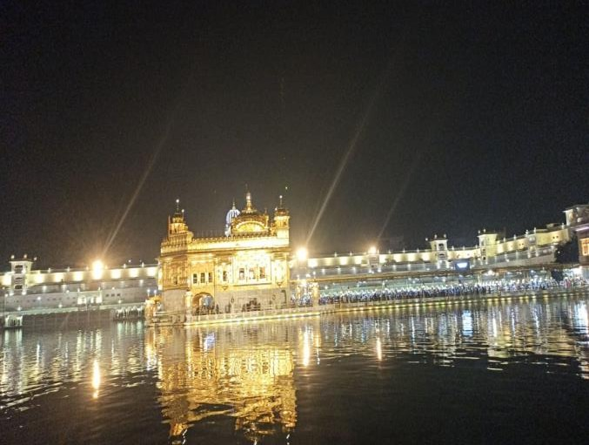We went to the Golden Temple around 7.45 p.m. We followed the tradition of covering of our hair with scarves. We then washed our hands and feet before entering the complex, as well as checked in our shoes. This place gives us a chance for the soul searching by just sitting besides the holy water and finding ourselves .

### DAY 16 – 20.02.23

We arrived at Delhi and checked in to the hotel around evening .There we are allowed for shopping at Karol Bagh.It was actually a terrific time as the crowd was more than any other places we visited .There we shopped whole heartedly and

energetically.Shopping was more fun at Delhi as most of us doesn’t know to speak

hindi yet we bargained .After shopping there was an exciting news awaited for us

. Yes !It was a DJ night , where all of us where dancing our soul out . It was more like a trail for farewell, and made us realise how important and beautiful past days are .And when he played the song ‘Mustafa Mustafa’ we did just realized that this beautiful college days are about to end in a couple of month . We held our arms around each other like it’s the last time we get to hold them .

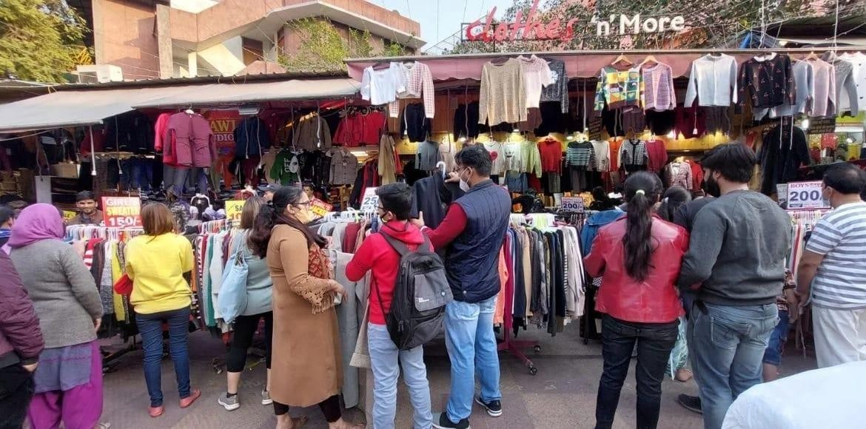

### DAY 17 – 21.02.23

On this day we went to National Agricultural Science Museum ,Library , India Gate , Gandhi memorial museum and the Indira Gandhi museum . The museum was the house of Indira Gandhi. As we entered the museum , a mysterious calmness swept upon all of us. Her house itself is developed as museum.It shows the hall of the house with an old TV , books , the dress she

wore at the time of her death. All the paintings and drawings which were made by her were displayed.Finally the place where she was assassinated is shown clearly and that was quite emotional when you stand by the sopt she was assassinated.Gandhi memorial museum showcases the life and principles of the father of our nation, M.K Gandhi. The Indira Gandhi Memorial was established to commemorate the India’s first female Prime Minister Indira Gandhi. It is housed in the building where Gandhi lived with her family during her premiership and where she was assassinated.

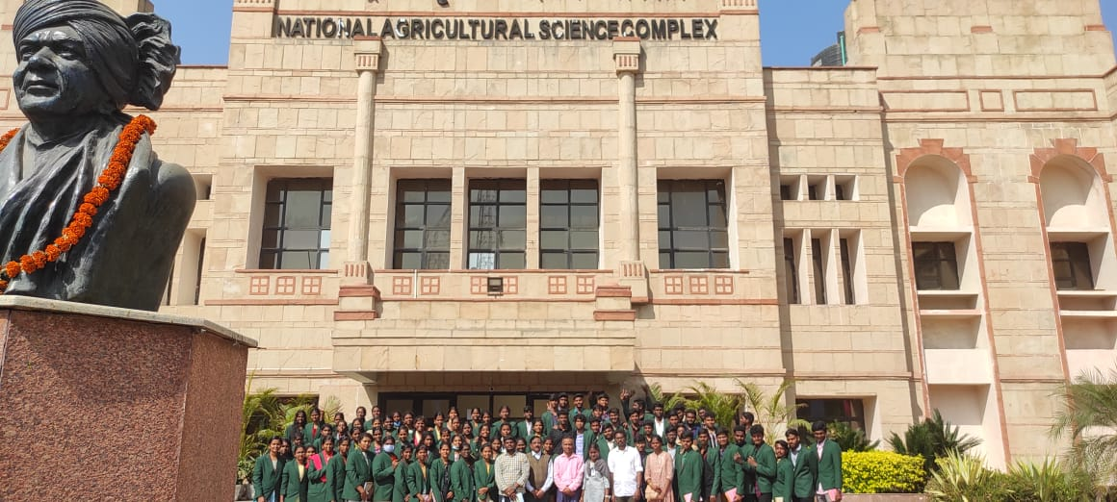

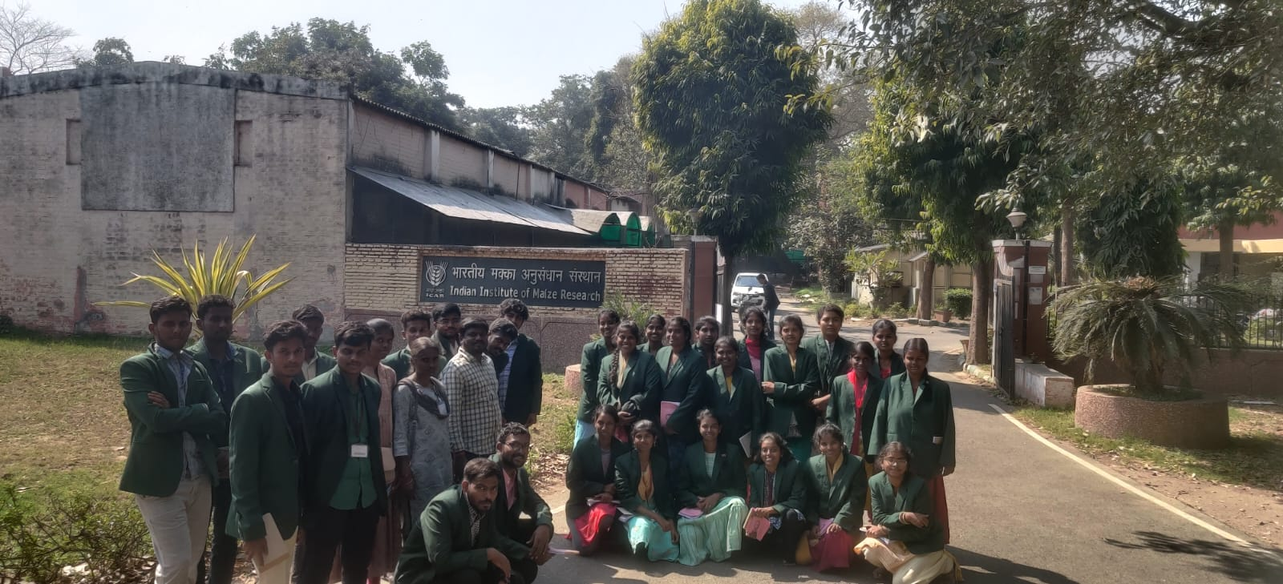

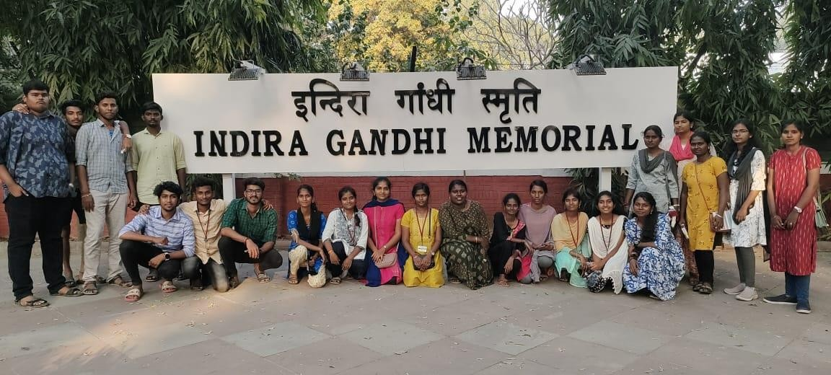

Then we concluded the trip by visiting the India gate which is a war memorial to around 84,000 soldiers of the British Indian army who died between 1914 and 1921 in the First World War.It is an enjoyable place where there is a long road to Rashtrapathi Bhavan .The names of the brave soldiers names were enbgraved on its walls. Overall it was a good experience and a thoughtful place to visit and hang on.

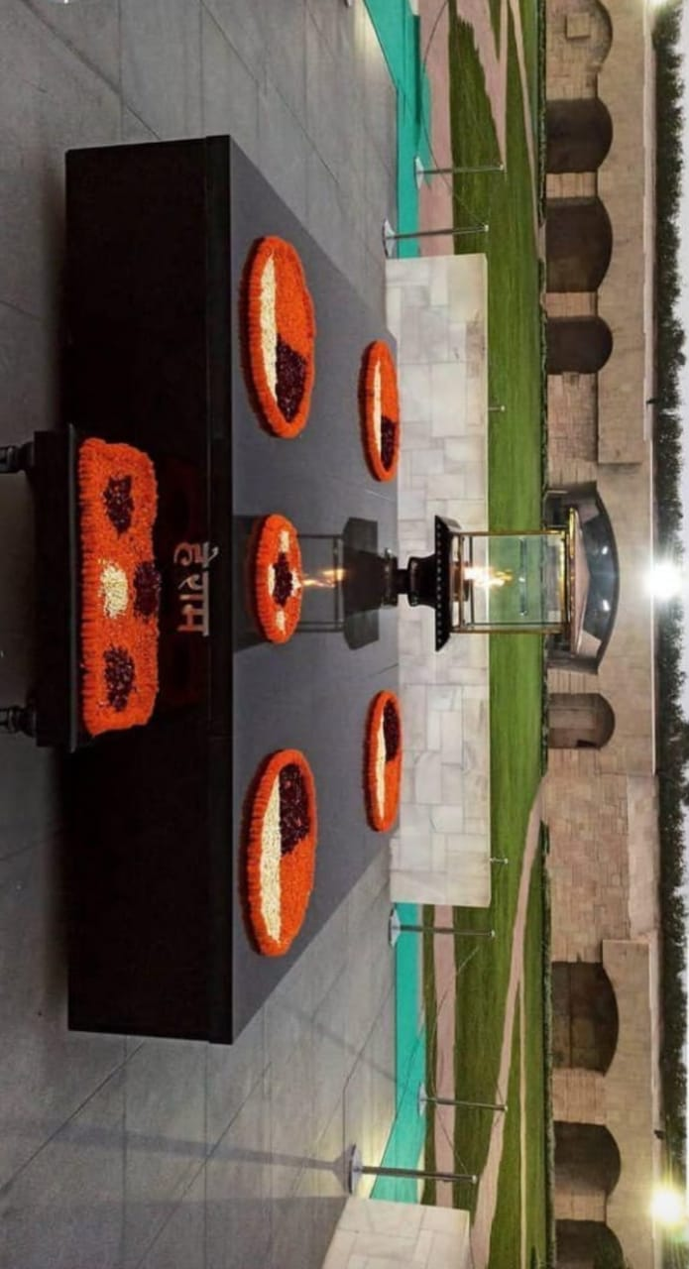

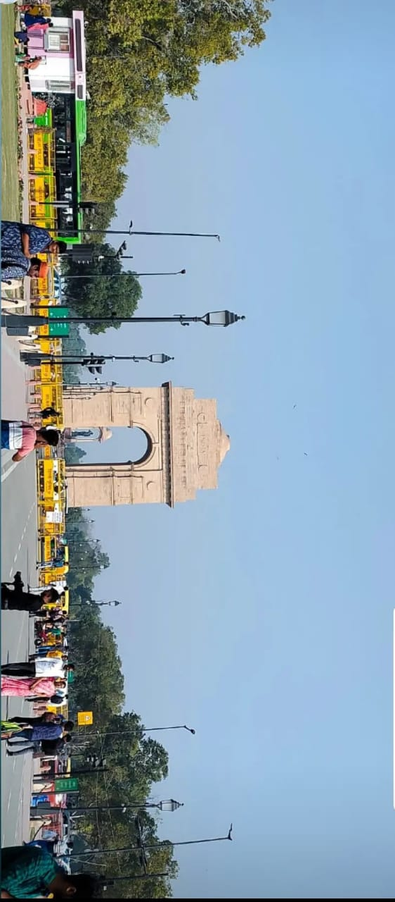

### DAY 18 – 22.02.23 To 23.02.23

The train left the station of Delhi as we all laid down owr backs on the train berths, we recalled all the moments we lived and the memories we created during this trip.

The first morning in the train was cold as expected. As we woke up , the scenery outside the window was breathe taking. This was a superfast train and we didn’t expect it to stop anywhere. As we moved South-wards on the map, the temperature increases and slowly the blankets were out , shortly the thermals, mufflers and shawls were in.

We knew we didn’t have much time before we are back to the pavilion.We sat,sang,danced, played a dumbcharade, clapped and enjoyed the really less time we could spend together. As the sun sets down the second day, we were counting back with much scepticism.. At 21st February we were back to what we call our home, ‘’Thanjavur’’.And with this our trip came to an end.

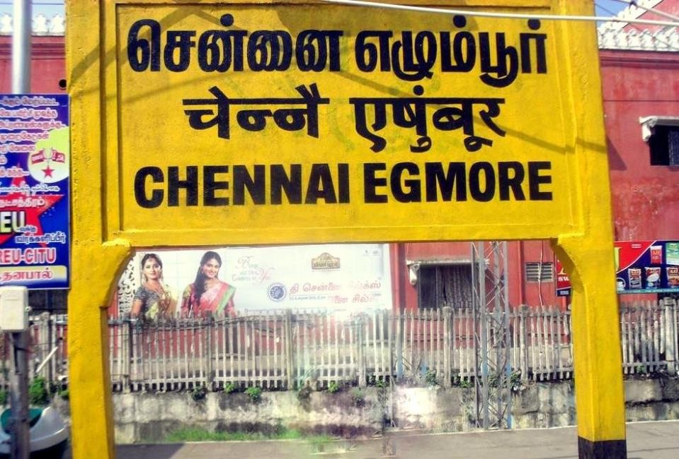

In the words of students ,

‘’Prior to leaving Thanjavur we hardly know each other except few of our batchmates, but we came back with a bunch of memories with other batchmates and seniors – Alphina Darling Kanmani .

‘’DJ night , which I hope no one is going to forget ‘’ – Suchit .

“A day in Ramoji Film City , from murmuring why the hell did they brought us here and not Wonderla to came out with a heavy heart . Brown parents would kick us out of the home if their children got tattoos but that didn’t stop us from having one . Yeah I had my first tattoo ’’. – Kiruthika .

It was such a fun trip around India with friends . Mr.Sreenivaasan is not only the trip guide but a friend that I’ll have for life – Sariq Sakthi .

‘’This was indeed a great experience . I will remember this journey throughout my life . I made memories to cherish forever – Dharani .

As we all dreamt of planning a trip but that never happened. And This was a moment where the biggest dream came true for me. – Rukkaiya Begum .

For all this we would cherish our trip .

**‘’THEY SAY TRAVELLING IS NOT ABOUT THE DESTINATION , ITS ABOUT THE JOURNEY’’**

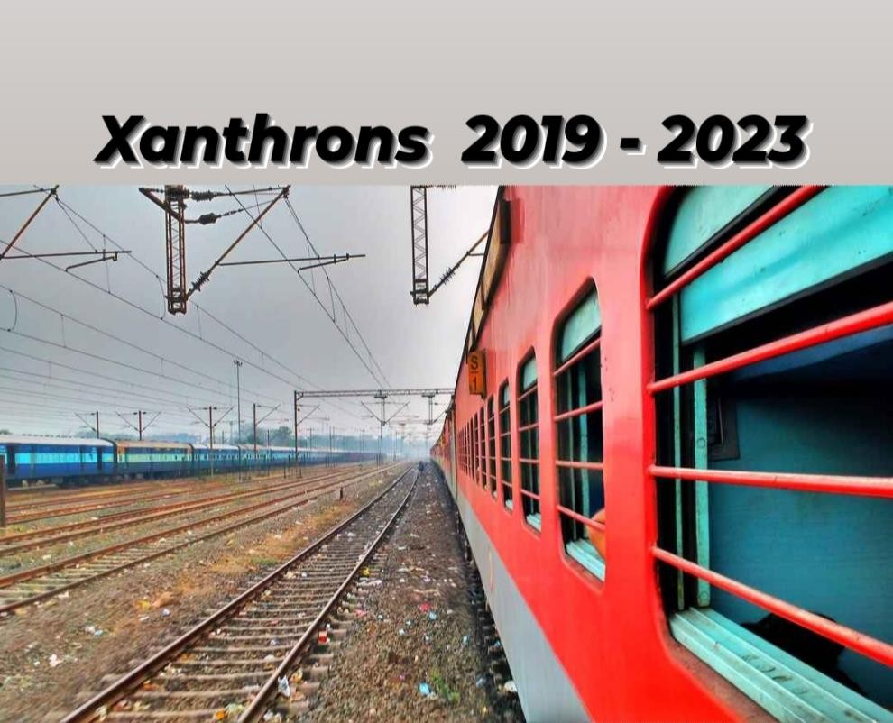

## ALL GOOD THINGS COMES TO AN END……

**BUT THE MEMORIES LINGER ON AND ON : ( :**